Project Design Phase-II
Data Flow Diagram & User Stories

Date | 31 October 2022
Team ID | PNT2022TMID45424
Project Name | Project -Emerging method for early detection of forest fire
Maximum Marks | 4 Marks

Data Flow Diagrams:
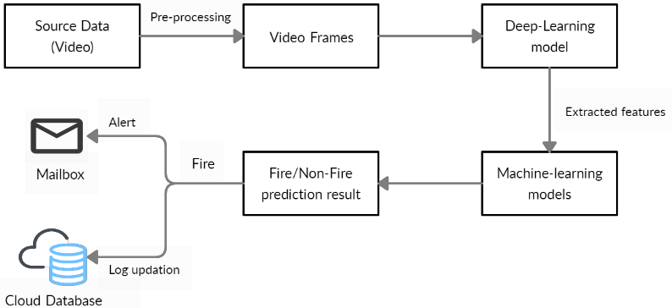

no fire detected
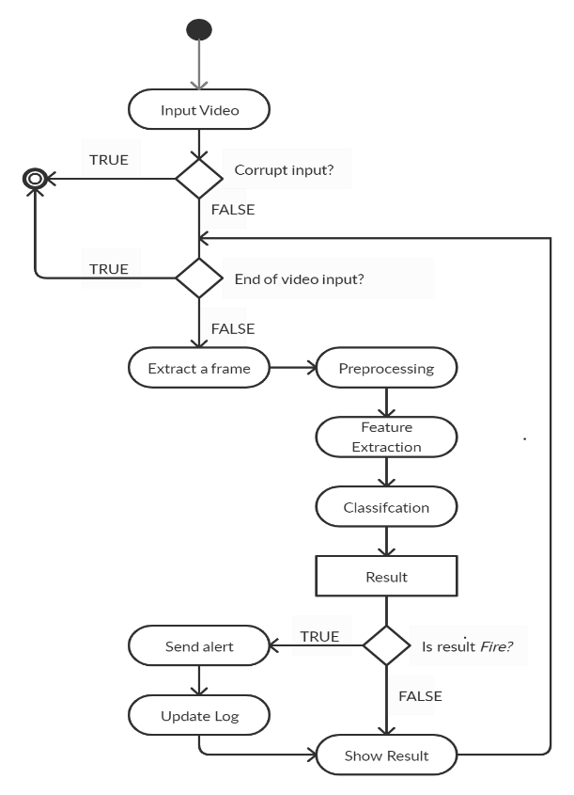

User Stories
Use the below template to list all the user stories for the product.
User Type | Functional Requirement (Epic) | User Story Number | User Story / Task | Acceptance criteria | Priority | Release
People who live near forest | Login | USN-1 | As a livelyhood, I want to inform the (forest fire)situationto the government. And to protect myself and my family from the forest fire. | I can use my mobile phone and I can inform the situation. | High | Sprint-1
Forest officer | login | USN-2 | As the forest officer, I want to identify the forest fire in early . | I can identify the fire by using cameras. And sensors. | High | Sprint-1
Tourist/ Trecking people | Login | USN-3 | As the humanity based activity, I want to inform and protect myself and the people, aminals and others from forest fire | I can use my mobile phone and I can inform the situation. | High | Sprint-1
Passersby | Login | USN-4 | As the humanity based activity, I want to inform and protect the people, aminals and others from forest fire | I can use my mobile phone and I can inform the situation. | High | Sprint-1

